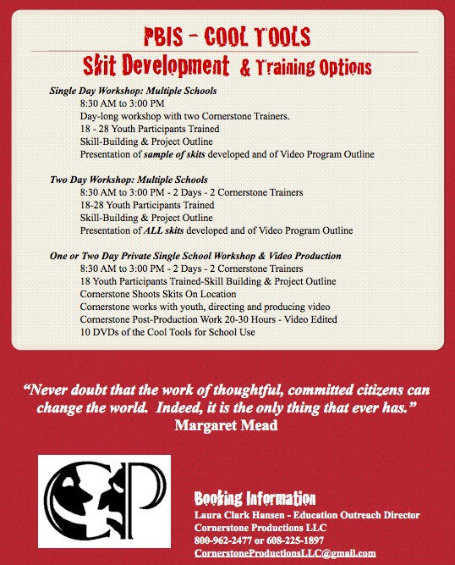
CESA #3 SAFE AND HEALTHY SCHOOLS NETWORK
presents
CORNERSTONE PRODUCTION’S
Student Leadership/Peer Drama Workshop
With Laura and Paul Hansen

Objectives :
• Students learn the SIX STEPS OF EFFECTIVE LEADERSHIP
• Students participate in team-building interactive improvisational acting and skill building exercises that will help them to bond as a team and prepare for scene work.
• Students identify several topics of concern in their community.
• Working as a team, and implementing the SIX STEPS OF EFFECTIVE LEADERSHIP, students develop 1-2 scenes that will
1. identify the issue,
2. explore the problem,
3. propose solutions.
• Students learn a simple approach to use when facilitating a discussion with the audience about the topic.
• Students perform skit(s) for the assembled group and receive a video of the material they developed.
What is the Supporting Players© Training?
The training is a two-day intensive workshop. Your students will be guided through a creative process that helps them build performance skills, bond as a team, and create moving, entertaining skits designed to be presented in your community. They learn the basics of: building a character, improvising short scenes, and effectively staging them.

Please do register early!!
Training is limited
to 28 students.

At this time I only have one session scheduled. If there is enough interest we can schedule another session. You will also notice that the price has increased, but advisors can attend at no charge.

WHEN AND WHERE: October 28 & 29 - 9:00 a.m. to 2:00 p.m. at CESA #3 in Fennimore.

COST: $100 per student 2013/14 Safe and Healthy Schools Pledge Network Members, $200 per student Non-members. (Includes training, materials, breakfast, lunch and snacks)

NOTE: No refunds will be given, but substitutes will be accepted.

WHO SHOULD ATTEND? Districts are encouraged to bring teams of Middle School or High School students. (Remember a mix of types, gifts & personalities makes for a successful troupe!) One - two advisors also need to attend and commit to this project. This year there is no charge for the advisor (limit of 2 per district).

REGISTRATION: http://login.myquickreg.com/event/event.cfm?eventid=7402

Register adults and provide number of students and names in NOTES box.

QUESTIONS? - Call Deb Goold 608-822-2147 – email dgoold@cesa3.k12.wi.us

DEADLINE: Friday, October 11, 2013

